D7PAM2000 Applied Data Science 1

Assignment 1: Data Visualisation

Table of Contents

Table of Figures 1

Data Link 1

GitHub

Line Plot 1

Grouped Bar Chart 2

Pie Chart 2

# Table of Figures

Figure 1 Shows line plot for the Employment rate by type of Graduation in UK 1

Figure 2 Shows grouped bar chart for Median Salary for Various Graduate types 2

Figure 3 Shows pie chart for median Salary of Various Graduate of Male and Female in 2021 (Pounds) 2

# Data Link

The [Data Link](https://explore-education-statistics.service.gov.uk/find-statistics/graduate-labour-markets/data-guidance) for the dataset that we have chosen is related to the Graduate labour market from the gov.uk link given in the assignment.

<https://explore-education-statistics.service.gov.uk/find-statistics/graduate-labour-markets/data-guidance>

# GitHub Link

# <https://github.com/sanzds/7PAM200_Applied_Data_Science>

# Line Plot

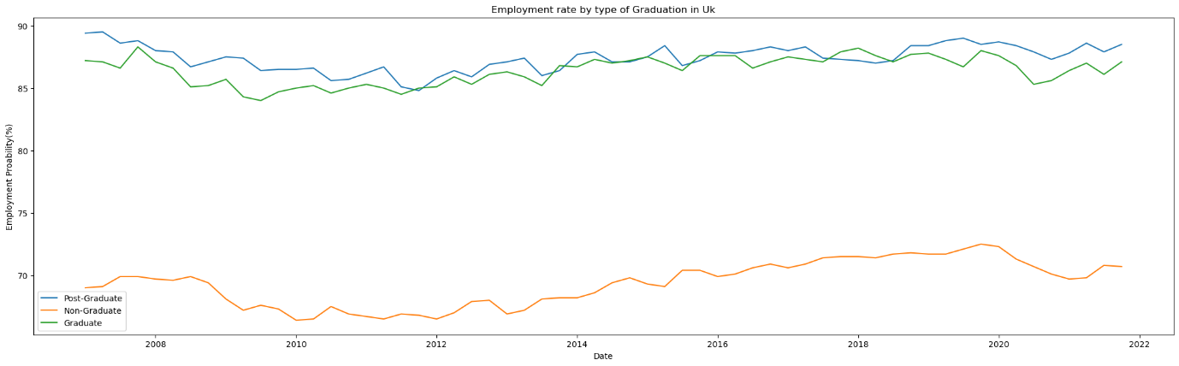

Figure 1 Shows line plot for the Employment rate by type of Graduation in UK

Using the line graph in the figure above, we can see that postgraduates have generally been paid more than undergraduates in the workforce, with the exception of the years 2011–2019, when the two groups have been paid similarly. In addition, we saw a strong association in the trends between those of master's degrees with those of Graduates, but no correlation of trend with Non Graduates. The employment rate for those without college degrees has, however, risen generally throughout the time period.

# Grouped Bar Chart

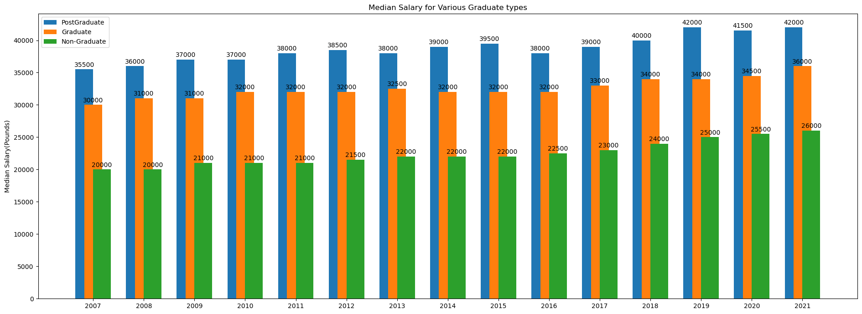

Figure 2 Shows grouped bar chart for Median Salary for Various Graduate types

We could make observations in the above figure, that the median salary gap between postgraduate graduates and non-graduates is having the slight fluctuations. It’s mailny increasing with time and the most difference was recorded in 2019 between post graduated and graduates. In 2019 the median salary gap between grads and post grads was 8000 while the highest Median salary was recorded in 2021 and 2019 for postgraduates.

# Pie Chart

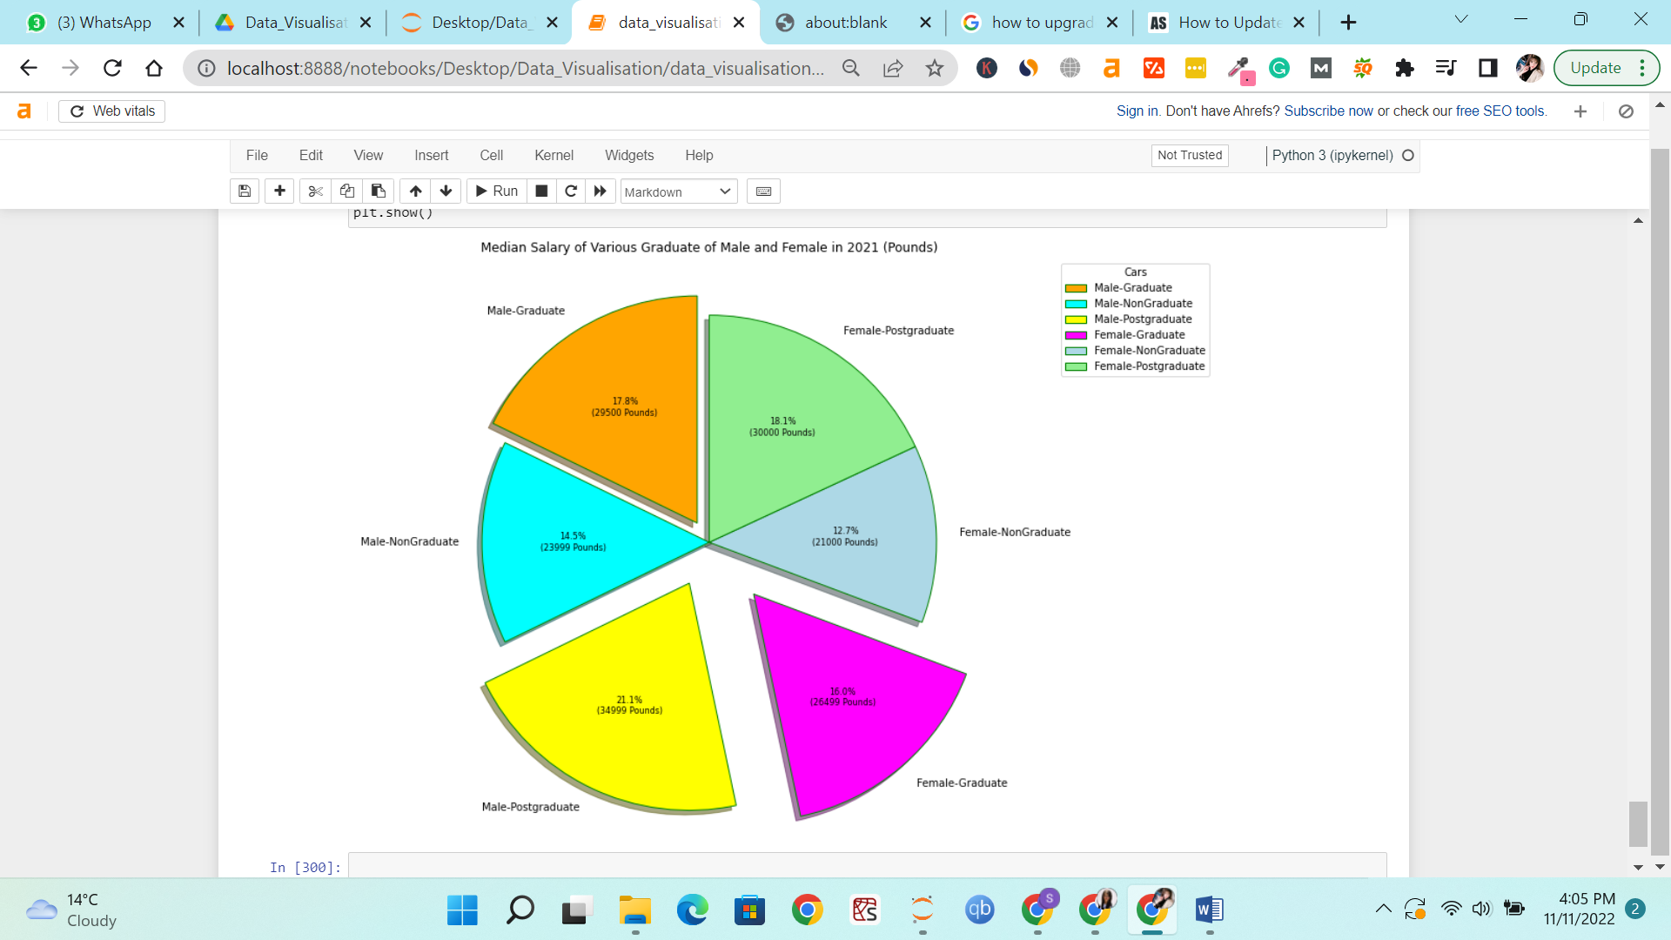

Figure 3 Shows pie chart for median Salary of Various Graduate of Young Male and Female in 2021 (Pounds)

The Figure above is the pie chart that shows the various portions of median salary that young(21-30) people of both genders have received with respect to their qualification in 2021. We could observe that Male-Postgraduate receives the most salary followed by Female Postgraduates. While the lowest is received by the Female Non Graduates.